Git:
- Create remote repository.
- Sign in to https://github.com/login with username and password.
- Create new – New repository
- Repository Name - SecondProject_React_Frontend_Development
- Click “Create Repository”

URL - https://github.com/Lohith2312/SecondProject_React_Frontend_Development.git

- Create Local repository.
- Go to D drive and create a folder React_Project_Lohith
- Open command prompt and go to above folder React_Project_Lohith
- Type command “git init” to initialize local directory.

- Connect Remote repository to local repository.
- Type command “git remote add origin https://github.com/Lohith2312/SecondProject_React_Frontend_Development.git” from command prompt and within directory React_Project_Lohith
- Type “git remote -v” to know remote repository URL (fetch and push)
- Created and saved document “Project_documentation” at local directory D:\ React_Project_Lohith
This document explains detailed project work.
- git add .
- git commit -m “initial commit1”
- git push -u origin master (while master is the working branch name. To get current branch run “ git branch” command.
- Now file Project_documentation is pushed to remote repository.

How to Run
- Create project:
npx create-react-app hr-portal
cd hr-portal

- Replace src/ with the structure below.
- Add db.json at root.
- Install dependencies:
npm install react-router-dom

- - Run JSON Server:
npx json-server --watch db.json --port 5000
- Start React app:
npm start

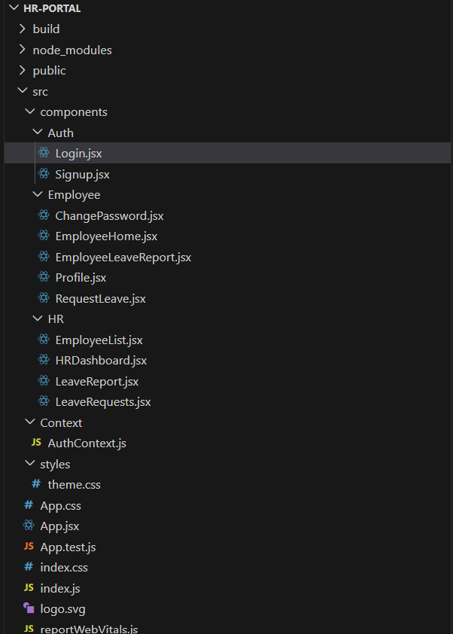

One/two-line concise file descriptions -
- package.json: project metadata, dependencies, scripts.
- README.md: short usage/setup instructions.
- db.json: fake DB for JSON server (users/employees/leaves).
- index.html: single-page app container.
- index.js: mounts React app and Auth provider.
- App.jsx: route definitions + role-based protection.
- AuthContext.js: stores logged-in user state and login/logout methods.
- Login.jsx: login form and redirect logic by role.
- Signup.jsx: sign-up form writes new users.
- HRDashboard.jsx: HR main page with tabs + add employee.
- EmployeeList.jsx: HR employee table + delete action.
- LeaveRequests.jsx: HR pending leave table + approve/reject.
- LeaveReport.jsx: HR all leave history report.
- EmployeeHome.jsx: employee dashboard tabs (profile/request/report).
- Profile.jsx: employee profile view/edit.
- RequestLeave.jsx: request leave form functionality.
- EmployeeLeaveReport.jsx: employee leave history/status and cancel.
- ChangePassword.jsx: first-login change password flow.
- theme.css: core app CSS styling.

